Wireloop user manual

# 1 – Command line arguments

## ARM

You can custom the run by adding some parameters to the command line.

You can select on which arm you want to run the application by adding :

ARM_MODE=<<IP_ADDR>|WAND>

For example if I want to run the application on the haption arm at the address 131.254.154.172#6001, I will add :

ARM_MODE=131.254.154.172#6001

If I don’t want to use an arm, and I want to use the middle VR wand I can run the command line argument :

ARM_MODE=WAND

If no arguments are given, then the application run with the 131.254.154.172#6001 IP that is the left Scale-1.

Here is a short list of the IP address you may want to use, note that they could change :

127.0.0.1 : to use the virtuose simulator on a computed

131.254.154.16#5125 : to use the virtuose 125

131.254.18.52#5126 to use the virtuose 126

131.254.154.172#6001 to use the left scale1 arm

131.254.154.172#6003 to use the right scal1 arm

## BASE FRAME SELECTION

As the application start, you may want to specify a base frame, it’s an offset to position the wire loop on the virtuose/scale-1 handle.

For example :  
BASE_FRAME=(4.369,-0.378,-0.032)

Will specify the base frame (4.369,-0.378,-0.032) to the application, it’s also the default base frame if the argument is not specified.

# 2 – Use the application

## Global use

The goal is to put the wire loop through a pipe network without touching the pipe.

The wireloop can only collide with the pipe.

T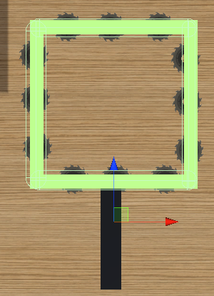

Figure 1 Wireloop

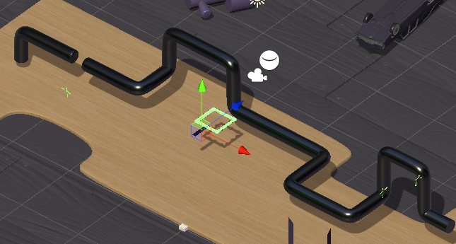

Figure 2 Pipe network

Pink checkpoint are dispatched along the pipe, you want to go through each one, when you successfully mark a checkpoint it turn green.

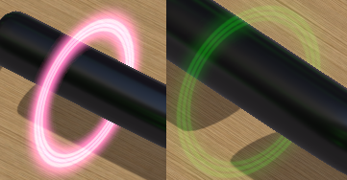

At any time you can turn back the circles to their pink color by pressing the virtuose/scale-1 handle button.

The collisions with the pipe are indicated but the wire loop turning red and emitting sparks.

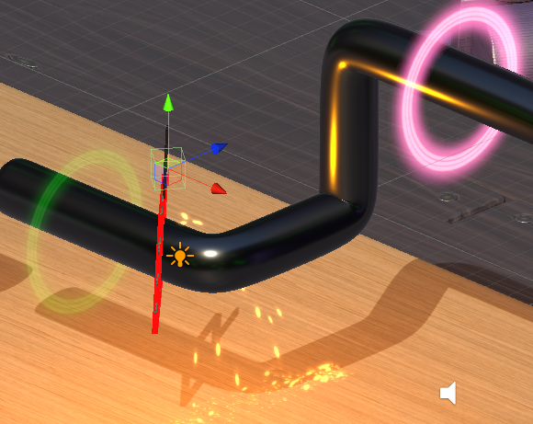

## Change wire loop size

You may want to change the wire loop size by pressing the “Left Arrow” key to size down and “Right arrow” key to size up the size.

You can also press the 3rd wand button to size down, and the 4th wand button to size up.

We do not recommend changing the wire loop size while having the wire loop to close to a pipe as it can result in unwanted collisions.

## Marker tool

A tool to mark the place with sphere and coordinate has been added, you can spawn it with the wand trigger and despawn it with the 2nd wand button.

## Toggle the custom bubble

By default, the application will use the custom bubble if running under a scale1 arm, and will disable the bubble otherwise.

You can manually activate or diactivate the bubble by pressing the “Left Shift + B” touchs on your keyboard.